Systems Analysis and Design
Phase 1 Use Case Diagram
D24130668
Nompumelelo G. Khumalo

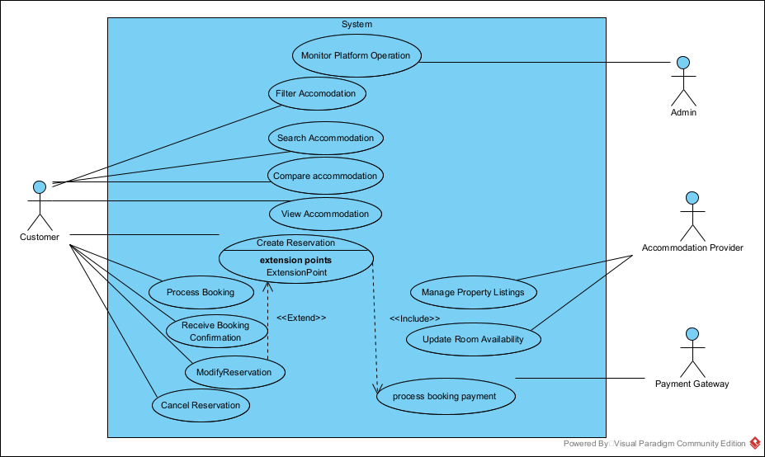

Actors in the Diagram
- Customer
  - Searches and books accommodation.
- Accommodation Provider
  - Manages property listings and room availability.
- Admin
  - Monitors the platform operation.
- Payment Gateway
  - Handles booking payments.
Customer Use Case
The Customer interacts with several system functions:
- Filter Accommodation
- Search Accommodation
- Compare Accommodation
- View Accommodation
- Create Reservation
- Process Booking
- Receive Booking Confirmation
- Modify Reservation
- Cancel Reservation
These functions represent the customer journey when booking accommodation.

Accommodation Provider Use Cases
The Accommodation Provider manages the property:
- Manage Property Listings
- Update Room Availability
The diagram shows:
Manage Property Listings
<<includes>>
Update Room Availability
This means updating room availability is part of managing property listings.
Payment System
The Payment Gateway interacts with:
- Process Booking Payment
When a reservation is created, the system processes payment through the external payment system.

